INFOCENTER SETUP NOTES
Raspbian Install
Go to http://www.raspberrypi.org/downloads/ and get the latest Raspbian image and prepare your SD card.

RPi Configuration
Once booted, I recommend some setting changes, using the command:
sudo raspi-config

Go through the following options/settings:
- Expand filesystem
- Change password as you like
- Set International options
I1 en_US.UTF-8
I2 timezone
I3 keyboard layout
Generic 104 key -> Other->English (US)->English (US)->No AltGr key->
No Compose key -> Yes-Ctrl+Alt+Backspace halts X-server
8) Advanced options
A2 hostname - in the case Infocenter
A4 enable ssh
A6 force audio to 3.5mm jack
Finish and reboot

Screen configuration
Setting up for the 1024x600 resolution hdmi screen. Infocenter is coded specifically for this resolution.
sudo nano /boot/config.txt

Adjust or add to file as follows:

disable_overscan=1 #non-intuitive, but this does work
overscan_left=16
overscan_right=16
overscan_top=8
overscan_bottom=8
framebuffer_width=1024
framebuffer_height=600
framebuffer_depth=24 #optional – better quality, but will degrade performance
sdtv_mode=0 #composite ntsc
sdtv_aspect=3 #16:9

ALSA Volume
Set volume output to max
alsamixer
Press up arrow to increase volume to 100%, then press Esc to exit

PACKAGE INSTALLS

Google API Python Client
(This install requires that Setuptools be installed on Python first (search web for install steps)

Download google-api-python-client-1.2.zip (or newer)
Extract the contents to a folder of same name

Windows:
Copy folder to Python27 directory.
cd google-api-python-client-1.2
python setup.py install

Linux (RPi):
Copy folder to home directory
cd google-api-python-client-1.2
sudo python setup.py install

Music Player Daemon (MPD)
On the RPi install MPD and (if you like) the client MPC.
sudo apt-get install mpd mpc
Daemon mayl complain about network tag_cache directory. No problem. Let’s fix.
sudo nano /etc/mpd.conf

Look for ‘music_directory’ and change to point to your music files (optional).
Look for network option ‘bind_to_address’ and change from “localhost” to “any”.
Under volume control mixer you uncomment mixer_type “software”. This provides independent volume control of MPD output from the hardware ALSA volume setting.

sudo service mpd restart

Infocenter setup
Download all of the Infocenter files from github and place into a folder named ‘infocenter’. I put this into the ‘home’ directory on RPi, or the Python27 folder on my Windows machine.
Google API access is a bit involved, but is required if you want to see your calendar. First, Google requires that an OAuth client ID be setup. You’ll do this via Google Developers API Manager (https://console.developers.google.com/apis/credentials). Select Create credentials->OAuth client ID, choose Other for Application Type and set its name to be ‘Infocenter’. Then, click on the newly created Infocenter credentials. From there click ‘Download JSON’ to get the credentials file. Rename it to ‘client_secret.json’ and move it to your infocenter folder.
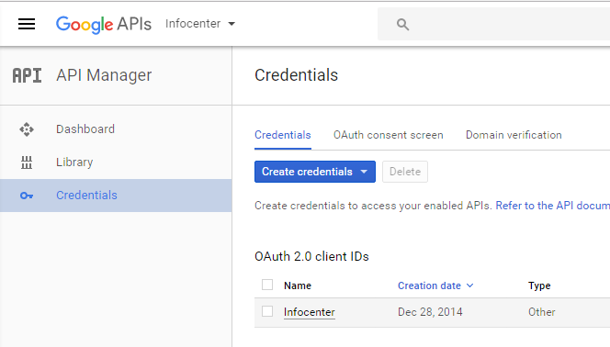
Next Google is going to require your authorization to connect to your Google calendar from Infocenter. When first run, infocenter will attempt to setup the authorization file. If run from a GUI, it should launch a web browser and take you to a Google login (notes on how to launch infocenter appear below). Follow the on-screen steps, as presented by Google, to allow read access to your calendar. This creates a token that will be saved to the folder path ‘/.credentials/calendar.json’ within your home directory. If the browser doesn’t launch, you should be able to copy and paste the URL shown in the console into a browser to get the authentication going. You’ll log in to your Google account and see the authorization screen as shown below. Note that if you create your /.credentials/calendar.json file on your PC, you can make this folder on your RPi and copy in the json file.
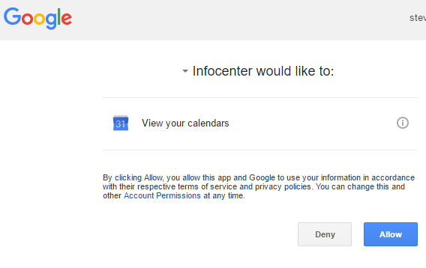

The yahooweather.py class is defaulting to my home town. You can either change the class __init__ or edit main.py and look for the initialization of the weather object and pass your location as a parameter (location = ‘town, state’).
My HDMI screen had a touch interface, which worked fairly well, but was calibrated very different from the mouse. Main.py was setup to use mouse on my windows machine, but touch on the RPi. You can set MOUSE to True, to force the mouse calibration.
To start infocenter, run main.py. On the RPI, you needn’t be in the desktop. From the Linux console just enter:
python main.py
For Windows, open main.py in Python’s IDLE and select run. You can also run infocenter from RPi’s desktop. That may be helpful when first setting up Google Calendar authorization.
MPD is a linux only application, so to fully use infocenter on a windows PC, you need a linux machine to run MPD. When I run the infocenter code on my PC it connects to the RPi MPD server by looking for the host name ‘infocenter’ (that’s what I named my RPi). That way the PC has full infocenter functionality, but it’s the RPi that actually plays the audio.
Another cool trick is to download the phone app MPoD. From my iPhone, this allows me to see the RPi MDP playlist, hit play, pause and change volume. Pretty slick. Don’t hit stop, or it will clear the playlist. You’ll have to restart infocenter if to get the playlist back.

